- The dermal tissue/epidermis- The epidermis or the dermal layer is the external layer of the stem that is made up of a single layer of cells and covers the outer stem to protect the internal delicate tissues of the plant. The epidermis can also sometimes have a thicker and rigid outer covering called bark that is more coarse and firm and functions to provide protection and rigidity to the plant body.
- Ground tissue- The ground tissue forms the bulk of the stem and is present between the epidermis and the inner vascular tissue. It is divided into two regions, cortex and pith.
- Vascular tissue- The vascular tissue is a network of complex tissues that contains several types of cells performing a diverse array of functions. The xylem conducts water from the underground root system to the different parts of the plant. The phloem is a cylindrical tube-like tissue that conducts organic nutrients and the food prepared by the leaves to all other parts of the plant. The xylem and phloem are arranged in specific vascular bundles with or without a strip of thin-walled cells called cambium. This cambial layer is responsible for secondary growth and is not seen in monocot plants.

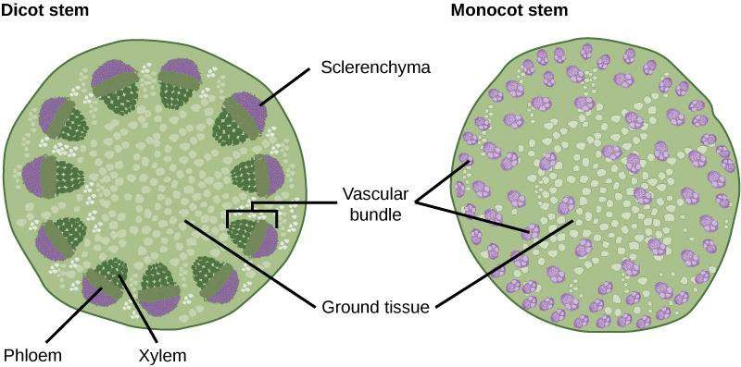

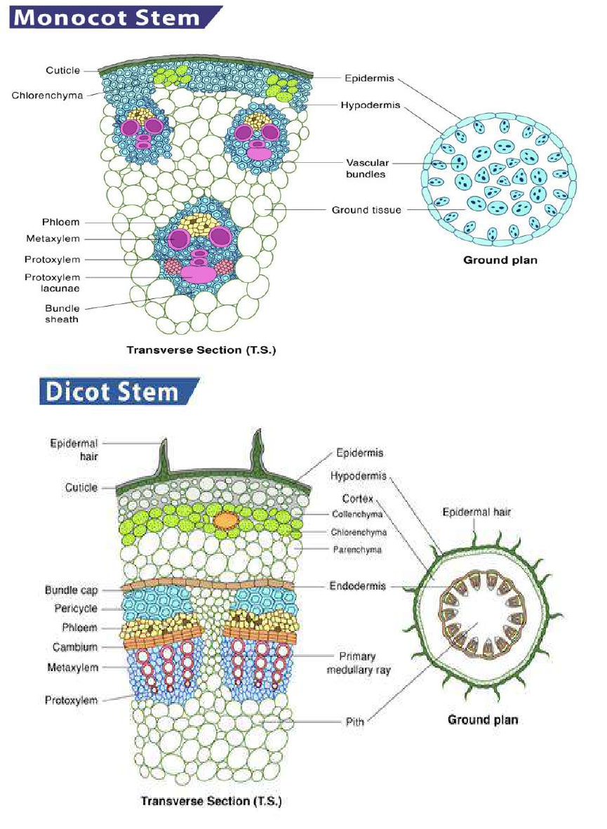

Ground tissue system in dicot stems
A dicot stem consists of hypodermis, cortex, endodermis, pith and medullary rays. Hypodermis is the layer just below the epidermis. It is made up of collenchyma or sclerenchyma cells depending upon the plants. In plants, tissue of unspecialised cells lying between the hypodermis and the endodermis is cortex.

Endodermis will usually be single layered rectangular cells lying just below the cortical layers. Endodermis are made up of starch grains, hence called starch sheath. A pericycle is a thin layer of plant tissue between the endodermis and the phloem. Pith is composed of undifferentiated parenchyma cells, which help in the storage of nutrients in young plants. Medullary rays are the strips of parenchyma which are present between vascular bundles of the dicot stem. They separate xylem and phloem bundles.
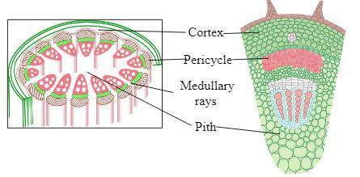
Ground tissues of dicot stem

Ground tissue in monocot stems
A monocot stem consists of hypodermis and ground parenchyma. It is not differentiated as cortex, endodermis, pericycle and pith. Vascular bundles are scattered in the ground tissues of monocot stems. The ground meristem is largely responsible for storage of food.
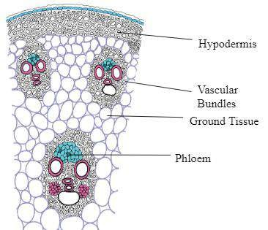
Ground tissues of monocot stem

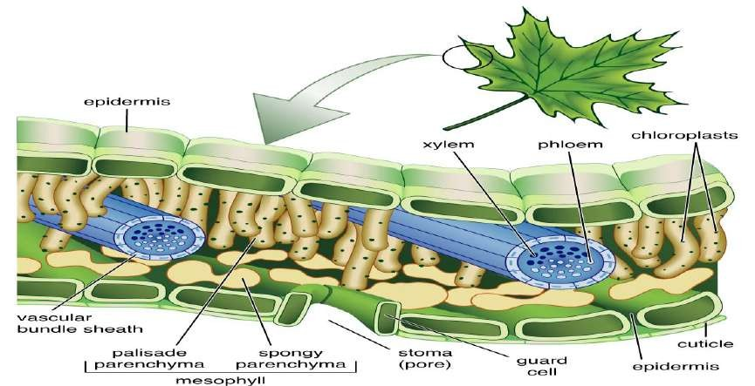leaf, Any usually flattened green outgrowth from the stem of a vascular plant. Leaves are the primary site of photosynthesis for most plants and manufacture oxygen and glucose, which nourishes and sustains both plants and animals. Leaves and stem tissue grow from the same apical bud. A typical leaf has a broad expanded blade (lamina), attached to the stem by a stalk like petiole. The leaf may be simple (a single blade), compound (separate leaflets), or reduced to a spine or scale. The edge (margin) may be smooth or jagged. Veins transport materials to and from the leaf tissues, radiating from the petiole through the blade. They are arranged in a netlike pattern in eudicot leaves and are parallel in monocot leaves. The leaf’s outer layer (epidermis) protects the interior (mesophyll), whose soft-walled unspecialized green cells (parenchyma) produce carbohydrate food by photosynthesis. In autumn the green chlorophyll pigments of deciduous leaves break down, revealing other pigment colours (yellow to red), and the leaves drop off the tree. Leaf scars that form during wound healing after the leaves drop are useful for identifying winter twigs. In conifers, evergreen needles, which are a type of leaf, persist for two or three years.

Dermal Tissue:
The epidermis of a leaf is different on the adaxial (upper) and abaxial (lower) surface. The upper leaf surface has few or no stomata compared to the lower surface.
Trichomes (hairs) may cover one or both surfaces. The epidermal cells are usually covered with a waxy cuticle which reduces water evaporation from the leaf, and also reduces gas exchange.

Ground Tissue:
The mesophyll (the ground tissue in the middle of the leaf) is the site of photosynthesis. In most plants (especially dicots) the mesophyll is made up of two distinct layers.
The palisade parenchyma lies just under the epidermis and consists of elongated, cylindrical parenchyma cells that are arrayed perpendicular to the leaf surface. This layer maximizes exposure of the chloroplasts to the sun. Just under the palisade parenchyma is the spongy parenchyma.
The Spongy parenchyma consists of irregular cells clustered together to create large air spaces between cells.
The air spaces aid in gas exchange between the leaf and the outside air. The air spaces in the mesophyll are continuous with air spaces adjacent to the stomata.
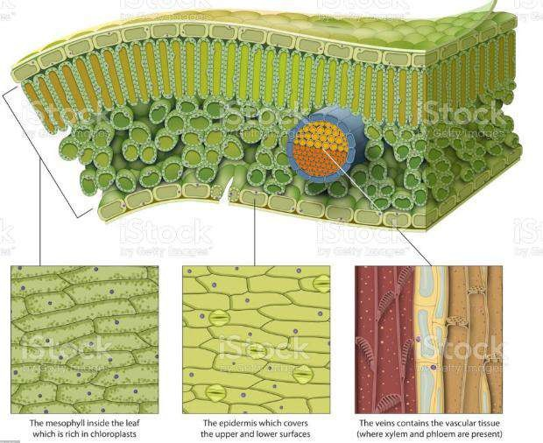
Parts of leaf
Vascular Tissue:
the xylem and phloem in leaves are confined to vascular bundles or veins.Veins are surrounded by a layer of cells call the bundle sheath.
The bundle sheath can be composed of parenchyma, colenchyma, or fibers.

5

The parenchyma cells are typically modified as transfer cells that aid in movement of organic solutes from the mesophyll parenchyma cells to the phloem sieve tubes in the leaf. No cell in the mesophyll is more than two or three cells from a vascular bundle.
The xylem in the vascular bundle is found on the upper (adaxial) side of the vascular bundle while the phloem is found on the lower (abaxial) side.
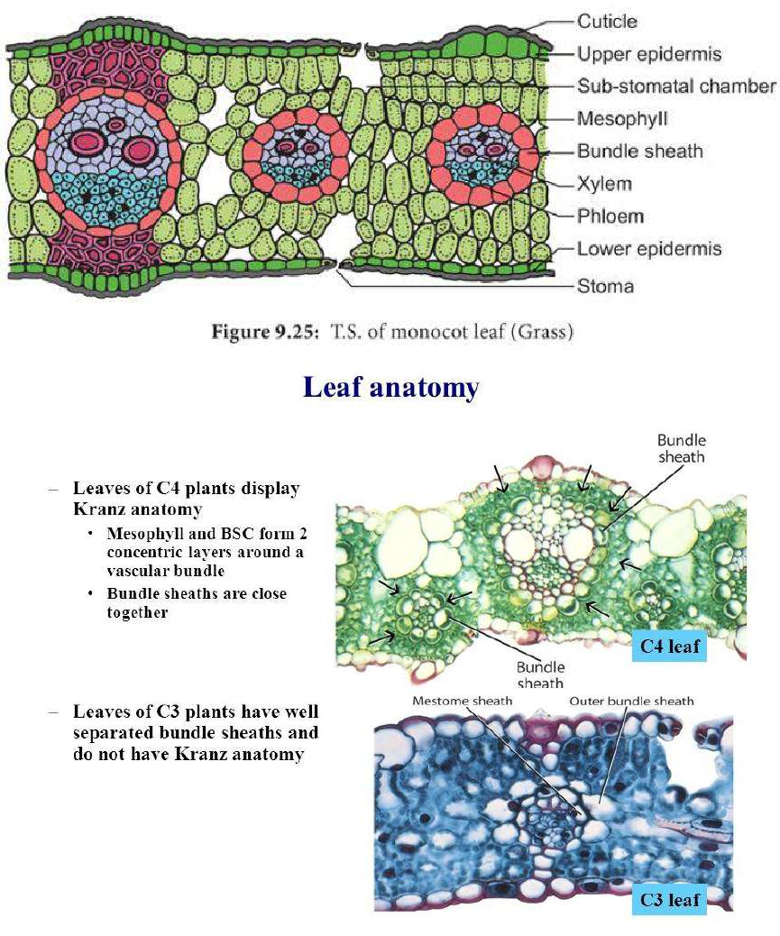

6

Fruit anatomy
Before going into types of fruits, it may be important to understand some basic fruit anatomy. Pericarp is a term used to describe the tissues of a fruit surrounding the seed(s). It mainly refers to the wall of a ripened ovary, but it has also been used in reference to fruit tissues that are derived from other parts of the flower. Pericarps consist of three layers (although not all fruits have all layers): endocarp, mesocarp, and exocarp (also known as epicarp). The pericarps of true fruits consist of only ovarian tissue, while the pericarps of accessory fruits consist of other flower parts such as sepals, petals, receptacles.
Fruits can be either fleshy or dry. Tomatoes are fleshy fruits, and dandelion fluffs are dry fruits. Dry fruits can be further broken down into dehiscent fruits and indehiscent fruits. Dehiscent fruits – like milkweeds and poppies – break open as they reach maturity, releasing the seeds. Indehiscent fruits – like sunflowers and maples – remain closed at maturity, and seeds remain contained until the outer tissues rot or are removed by some other agent.
Most fruits are simple fruits, fruits formed from a single ovary or fused ovaries. Compound fruits are formed in one of two ways. Separate carpels in a single flower can fuse to form a fruit, which is called an aggregate fruit; or all fruits in an inflorescence can fuse to form a single fruit, which is called a multiple fruit. A raspberry is an example of an aggregate fruit, and a pineapple is an example of a multiple fruit.

The pericarp is divided into three distinct sections:
The first is the endocarp, or inner layer or better known to most people as the hard pit of the fruit. Inside the endocarp is the seed of the fruit.
The second section is the mesocarp, or middle layer and is what most people would consider the flesh of the fruit and is the majority of the mass.
The exocarp, or the outer layer makes up the skin of the fruit.
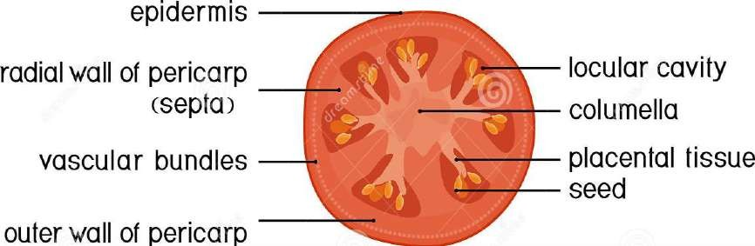
Part of fruits

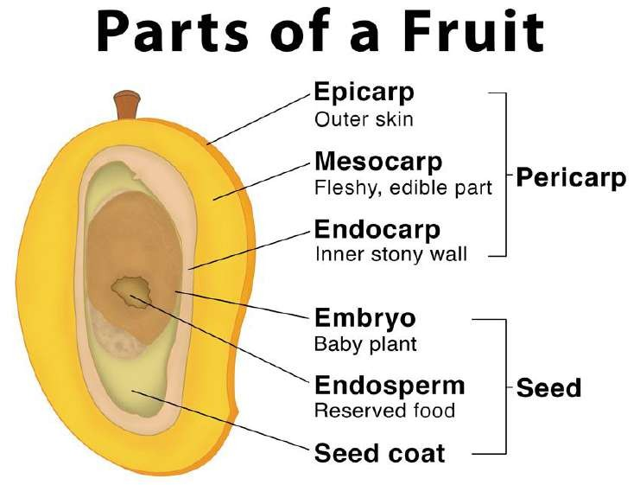

External Seed Anatomy
  - Seed coat: The protective, outer layer of the seed. Seed coats develop from the integuments of the ovule.
  - Micropyle: A tiny hole through the seed coat.
    - Initially, this is the hole through the integuments utilized by the sperm to fertilize the egg.
    - Later, this hole allows water to enter the seed during imbibition.
  - Hilum – The scar from the funiculus.

    - The funiculus is essentially the (umbilical cord) that attached the parent plant to the developing seed. The parent plant must transfer enough resources into the developing seed that the embryonic plant can grow its first true leaves and begin feeding itself through photosynthesis.
    - Thus, the hilum is equivalent to a person’s belly button.

Internal Seed Anatomy
Cotyledon – The embryonic leaf of seed-bearing plants consisting largely of energy-storing proteins that nourish the embryo as it grows. The cotyledons are the first structures out of a germinating seed. Monocots have only a single cotyledon in the seed. Dicots have two cotyledons in their seeds. Cotyledons are essentially the “baby food” for the growing embryo, but they are not the only energy-storing tissue found in seeds.

Angiosperms (the flowering plants) have both endosperm and cotyledons while gymnosperms (the non-flowering plants) have only a nutritive nucellus. Monocots and dicots utilize their cotyledons differently.
    - Monocots use their cotyledon energy to grow the embryo inside the seed and then rely on the endosperm to provide the energy to germinate. Thus, the bulk of monocot seeds is the endosperm.
    - Dicots use the endosperm as fuel to grow the embryo. The energy for germinating comes from the two cotyledons that make up the bulk of these seeds.
  - Embryonic plant – The young sporophyte in the seed that consists of the plumule, epicotyl, hypocotyl, and radicle.
    - Plumule – The top of the embryonic plant that represents the shoot or embryonic stem.
    - Epicotyl – The very tip of the plumule. This part of the embryonic stem is above the embryonic attachment to the cotyledons.
      - In monocots, the epicotyl will produce the first true leaves of the plant. Monocot epicotyls are surrounded by a protective sheath referred to as the coleoptile.
    - Hypocotyl – The part of the embryonic stem that is below the attachment point of the cotyledons. The hypocotyl is directly above the embryo’s root.
    - Radicle – The embryonic root.
      - In monocots, the coleorhiza is a protective sheath that surrounds the radicle.
